**C:\Users\kev\AppData\Local\Microsoft\Windows\Temporary Internet Files\Content.IE5\1NKV1X23\MC900242899[1].wmfGreatest Warrior**

*Your task: Complete a chart like the one below to compare two warriors from history. You will need to do some outside research using books or the Internet. Class notes will not be enough!*

Pict

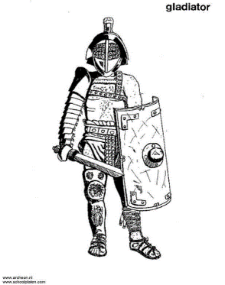

Picture of Warrior

(colored)

Warrior Name Gladiator

Civilization Rome

EXAMPLE

**Offensive Tools:** *Write at least three sentences describing the offensive tools and weapons this warrior would use. Explain what they are and how effective they would be in battle.*

**Offensive Tools:** *Different types of gladiators had different offensive weapons. The most common weapon, however, was the gladius. It is a short sword designed for stabbing. It was incredibly effective because it could be**aimed easily to hit between the slots in the enemy’s armor.*

At the bottom of your chart or on the back of your paper write a story describing how a battle between these two warriors would play out. Include which would win the battle and why. The story must be at least two complete paragraphs in length.

**Training and skills:***Roman gladiators spent most of their lives training for battle so they were very skilled. They were also very motivated since any battle could mean death. However, they were trained to fight other gladiators one on one and may not have been very skilled against warriors trained different or in big battle situations.*

**Defensive Tools:** *Gladiators usually wore light leather armor. Some had large shields and others were given nets to use to wrap up enemy weapons. Some wore metal helmets as well. The lack of body armor was an obvious weakness for them but their other tools helped to make up for it.*

**Training and skills:***Write at least three sentences describing the training and skills of the warriors in this civilization. Explain how these skills would help the warrior in battle.*

**Defensive Tools:** *Write at least two sentences describing the defensive tools and armor of this warrior. Explain what they are and how effective they would be in battle.*